

Standard Operating Procedure
Cordless Drill

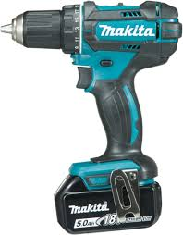
 | Dust Mask When required |  | Earmuffs/ Plugs When required
 | Safety Glasses |  | Close fitting Clothing
 | Safety Footwear |  | Long and loose hair must  be contained or restrained

PRE-OPERATIONAL SAFETY CHECKS

1. Check condition of Drill and Battery for damage.

2. Connect correct battery to drill, recharge battery if necessary.

3. Select correct drill bit making sure it is clean and sharp.

OPERATIONAL SAFETY CHECKS

1. Fit and hand tighten drill bit into keyless chuck.

2. Adjust appropriate speed and torque setting for task.

3. Use firm pressure but do not force tool.

4. Allow drill to stop completely before setting down or changing drill bit.

HOUSEKEEPING

1. Switch off and leave machine, bench and floor in a safe, clean and tidy state.

2. Make sure good housekeeping practices are in place to minimise any dust build-up.

POTENTIAL HAZARDS
Exposure to moving & rotating components Entanglement Ejected waste
Eye injury Wood chips Wood dust Braking drill bit

FORBIDDEN
Using Drill for anything apart from its purpose.


Editing Instructions: note that the Zest Safety Logos can be deleted, and your own company logos inserted. Font Colours can be changed to your company colour palettes.

Disclaimer: This resource document has been created with the utmost care and accuracy, referencing the latest guidelines and information available at the time of production. However, businesses or individuals using this free resource are advised to independently verify the accuracy of the information provided. For comprehensive and tailored advice, it is recommended to engage a qualified health and safety advisor.
For further free H&S documents visit www.zestsafety.com



