

Standard Operating Procedure
Sheet Sander

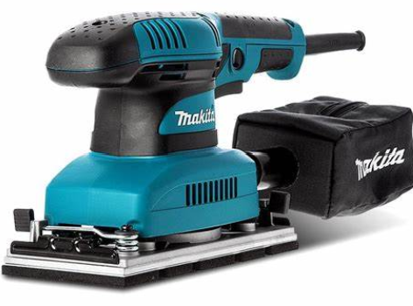
 | Dust Mask |  | Earmuffs/ Plugs
 | Safety Glasses |  | Close fitting Clothing
 | Safety Footwear |  | Long and loose hair must be  contained or restrained

PRE-OPERATIONAL SAFETY CHECKS
- Ensure this power tool has a suitable safe work area.
- Examine the power lead and plug for obvious damage and that the test date is current.
- Do not use dull or damaged abrasive sanding sheets.
- Check the sanding sheet is correctly fitted.
- Ensue you are familiar with the ON/OFF switch.

OPERATIONAL SAFETY CHECKS

1. This sander is not suitable for wet sanding.

2. Examine the material to be sanded for splits, loose knots and nails, etc.

3. Always select the correct abrasive and grade of sheet. Do not use sanding paper larger than is needed.

4. Always make sure a dust bag (or ducting) is fitted and emptied regularly.

5. Ensure the work piece is well supported and secure.

6. This sander is designed to be used with both hands. Keep fingers and hand away from moving parts.

7. Allow the sander to reach operating speed, then apply load gradually, do not use excessive force.

8. Always maintain a proper and steady footing.

9. Always hold the sander flat onto the work surface.

10. Avoid blocking ventilation slots, align holes in sheet with holes in pad (if present).

11. Avoid prolonged use and high pressures, this could overheat the motor.

12. Wait for the sander to stop before resting it on its side.

HOUSEKEEPING
- Return this tool to the appropriate storage cupboard.
- Leave the work area in a safe, clean and tidy state.
- Make sure good housekeeping practices are in place to minimise any dust build-up.

POTENTIAL HAZARDS
Moving, rotating and abrasive parts. Electricity Dust

Eye injury Noise Burns (friction)

Editing Instructions: note that the Zest Safety Logos can be deleted, and your own company logos inserted. Font Colours can be changed to your company colour palettes.

Disclaimer: This resource document has been created with the utmost care and accuracy, referencing the latest guidelines and information available at the time of production. However, businesses or individuals using this free resource are advised to independently verify the accuracy of the information provided. For comprehensive and tailored advice, it is recommended to engage a qualified health and safety advisor.
For further free H&S documents visit www.zestsafety.com



