

Standard Operating Procedure
Table Saw

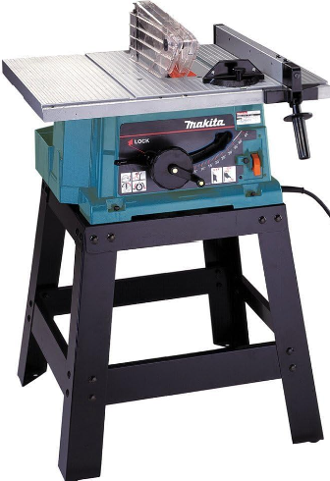

 | Dust Mask |  | Earmuffs/ Plugs
 | Safety Glasses |  | Close fitting Clothing
 | Safety Footwear |  | Long and loose hair must  be contained or restrained

PRE-OPERATIONAL SAFETY CHECKS
1. Check that all necessary guards are in position and are set to minimum clearances.
2. Check that the blade is in good condition and suitable for the product to be cut.
3. Locate and make sure you are familiar with the ON/OFF switch and emergency stop button.
4. Ensure all locks and stops are securely tightened.
5. Check material is free from defects, loose knots, twists and foreign matter such as nails etc.
6. Start the dust extraction unit before commencing work – if not interlocked.

OPERATIONAL SAFETY CHECKS

1. Stand out of the line of the blade when starting the saw.

2. Ensure safe and correct manual handling of large or heavy sheet panel materials.

3. Always allow the saw to reach the maximum revolutions before operating to avoid stalling the blade and overheating the motor.

4. Feed material only as fast as the saw will cut freely.

5. Maintain a balanced stance at all times so that you do not fall or lean against moving parts.

6. Do not overreach or use excessive force to perform any machine operation.

7. Sawing operations must be done slowly, smoothly and, whenever possible, without stopping.

8. Never remove off-cuts or waste materials while the saw is running.

9. Always use a push stick for removing waste and when cutting small work pieces.

10. Never cut free hand.

11. Never leave the saw running while unattended.

12. Reset guards and fences

HOUSEKEEPING
- Switch off and leave the machine and floor in a safe, clean and tidy state.
- Make sure good housekeeping practices are in place to minimise any dust build-up.

POTENTIAL HAZARDS
Exposure to moving & rotating components Pinch & squash Ejected waste
Eye injury Wood dust Splinters Manual handling

FORBIDDEN
Operating without the guard in place (unless the thickness of the timber covers the top of the blade)
Operating without the underside blade cover in place
Operating with any damage to the saw blade



Editing Instructions: note that the Zest Safety Logos can be deleted, and your own company logos inserted. Font Colours can be changed to your company colour palettes.

Disclaimer: This resource document has been created with the utmost care and accuracy, referencing the latest guidelines and information available at the time of production. However, businesses or individuals using this free resource are advised to independently verify the accuracy of the information provided. For comprehensive and tailored advice, it is recommended to engage a qualified health and safety advisor.
For further free H&S documents visit www.zestsafety.com



