

Standard Operating Procedure
Scroll Saw

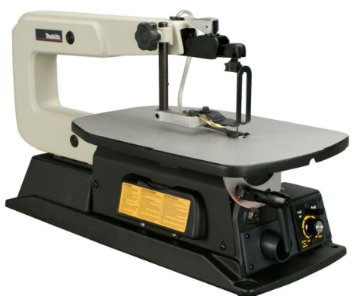
 | Dust Mask |  | Earmuffs/ Plugs
 | Safety Glasses |  | Close fitting Clothing
 | Safety Footwear |  | Long and loose hair must  be contained or restrained

PRE-OPERATIONAL SAFETY CHECKS
- Check that the machine and surrounding area is clear of debris.
- Check that the hold-down foot/blade guard is set and locked at correct height for material.
- Locate and make sure you are familiar with the ON/OFF switch and emergency stop button.
- Check the blade is suitable for the job (teeth pointing down) and is set to the correct tension
5. Use proper extension cord and inspect for damage and that the test date is current before using.

OPERATIONAL SAFETY CHECKS
- Always allow the Blade to reach the maximum revolutions before starting cut.
- Keep fingers off the line of cut at all times
- The work piece should be feed forward under even pressure and held firmly with both hands against the table and or fence for effective control.
- Do not force the work piece into the blade.
- Do not cut irregular stock (round or twisted)
- Always maintain a balanced stance so that you do not fall or lean against moving parts.
- Use a push stick when feeding material past the blade.
- Never adjust while the saw is running.
- Never leave the Band Saw running while unattended.

HOUSEKEEPING
- Switch off and leave the Band Saw and floor in a safe, clean and tidy state.
- Make sure good housekeeping practices are in place to minimise any dust build-up.

POTENTIAL HAZARDS

Exposure to moving & rotating components Pinch & squash Ejected waste
Eye injury Wood dust Splinters

Editing Instructions: note that the Zest Safety Logos can be deleted, and your own company logos inserted. Font Colours can be changed to your company colour palettes.

Disclaimer: This resource document has been created with the utmost care and accuracy, referencing the latest guidelines and information available at the time of production. However, businesses or individuals using this free resource are advised to independently verify the accuracy of the information provided. For comprehensive and tailored advice, it is recommended to engage a qualified health and safety advisor.
For further free H&S documents visit www.zestsafety.com



