RISK MANAGEMENT GUIDELINES Building & Construction

Risk Management Guide for the Building and Construction Industry

1. Introduction
The building and construction industry presents a complex array of risks due to the dynamic nature of construction sites, the involvement of multiple contractors and subcontractors, and the use of various tools, equipment, and materials.
Effective risk management is essential to protect workers, ensure compliance with legal requirements, and maintain project timelines. This guide outlines key strategies for [Your Company Name] to manage risks during building and construction.
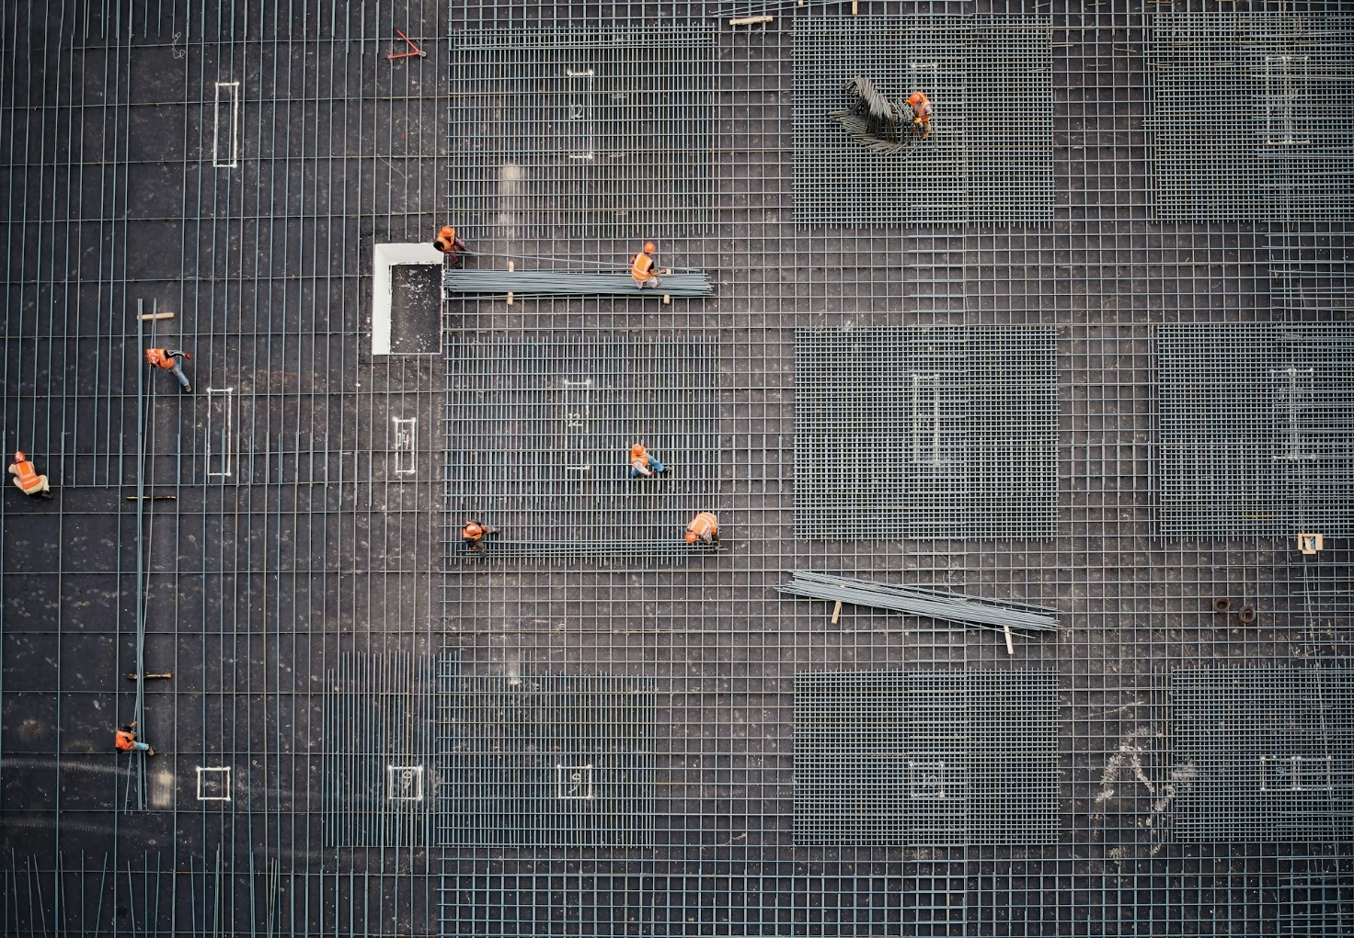

2. Contractor and Sub-Contractor Management
Managing contractors and subcontractors is critical for [Your Company Name] in ensuring a safe work environment. Key considerations include:
- Pre-qualification and Selection: The [name the role of the person, e.g. Project Manager] is to ensure all contractors and subcontractors are pre-qualified based on their safety performance, training, and compliance with legal requirements.
- Safety Inductions: The manager or supervisor of a worker is required to provide comprehensive site-specific safety inductions to all workers/contractors/sub-contractors before commencing work.
- Monitoring and Supervision: Managers and supervisors are required to regularly monitor the work of their workers/contractors and subcontractors to ensure they follow safety protocols and address any non-compliance promptly.
- Communication and Coordination: Managers and supervisors are required to establish clear communication channels and coordination mechanisms to manage the interface between different contractors on site such as toolbox talks, permit to work systems etc.
Reference documents:
- Contractor Prequalification forms
- Site-Specific Induction package
- H&S Observation & Monitoring form
- Site coordination / toolbox talk template

3. Tools and Equipment Risks
The use of tools and equipment in construction poses significant risks on [Your Company Name]’s building or construction sites. Effective management includes:
- Inspection and Maintenance: All workers/contractors/sub-contractors must regularly inspect and maintain tools and equipment to ensure they are in good working condition and meet safety standards.
- Training: All worker or contractor managers must ensure the provision of training to workers on the proper use of tools and equipment, including the use of personal protective equipment (PPE). This may be of way of inspecting training records (and maintaining a copy).
- Tagging and Testing: Workers/contractors/sub-contractors must implement a system for the regular tagging and testing of portable electrical equipment, tools, and extension cords to prevent electrical hazards as per [Your country name] legal standards. Copies of tag & test results should be inspected and retained by the [Name of role e.g. Project manager].

4. Risks of Falling Items and Building Frames/Concrete Panels
Construction sites often involve working at heights and the movement of heavy materials, which can lead to falling objects or materials. To manage these risks managers and workers must:
- Use of Barriers and Exclusion Zones: Implement barriers and exclusion zones to protect workers and the public from falling items.
- Safe Lifting Practices: Ensure safe lifting practices are followed, including the use of appropriate lifting equipment and trained personnel.
  - Cranes: prestart checklists must be completed, and a lifting plan developed before the lift occurs Operator must be trained for that specific crane.
  - Trucks with trailer mounted Hiab crane or side lifter (also known as ‘Side loader’, ‘Swing lift’): prestart checklists to be completed; maintain a 5-metre exclusion zone either side of the truck, and 1-metre front and back, during the lift. Operator must be trained for that specific side lifter or Hiab.
- Secure Storage: Store materials securely to prevent them from falling or collapsing.
Reference documents:
- Pre-start checklists for crane operation, or truck side lifter, or Truck with Hiab crane.
- Crane lifting plan
- SOP training; Crane operation.
- SOP training; Hiab Operation
- SOP Training; Truck with side lifter

5. Managing Multiple Workers/Contractors on Site
When multiple contractors work on the same site, the risk of incidents increases due to overlapping activities. Risk management strategies include:
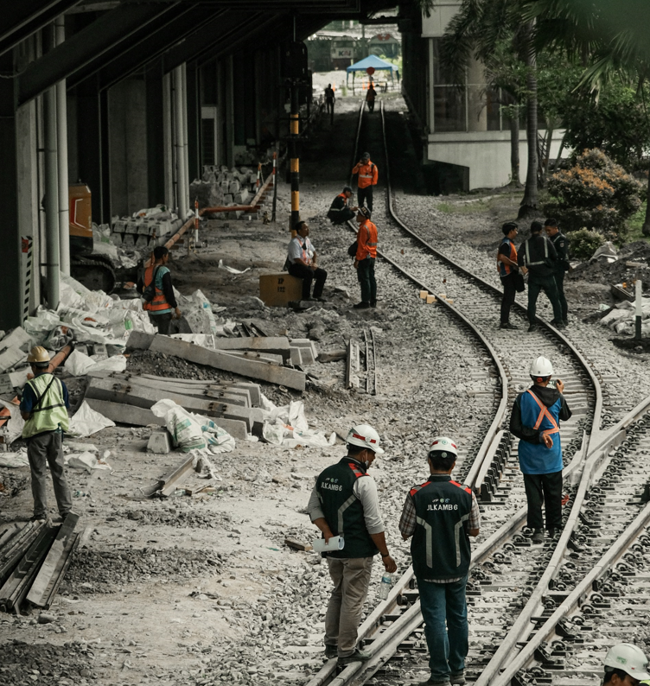
- Site Coordination Meetings: Hold regular site coordination meetings to plan and sequence work activities, identify potential conflicts, and agree on safety measures. Meetings shall be recorded and documented, with those present signing off and confirming that they have understood the information provided.
- Work Area Segregation: Clearly segregate work areas for different contractors to prevent interference and reduce the risk of accidents.
- Permits to Work: Use a permit-to-work system to control high-risk activities and ensure proper authorisation before starting work.
Reference documents:
- Site coordination / toolbox talk template
- Permit to Work forms

6. Separation of Workers from Moving Plant and Vehicles
Separation of workers from moving plant and vehicles is essential to prevent collisions and other incidents:
- Traffic Management Plans: [Name of role e.g. Project manager] must develop and implement traffic management plans to control vehicle movement and separate pedestrian walkways from vehicle routes.
- Spotters and Signage: [Name of role e.g. Supervisors] must use spotters to guide vehicle movements and erect clear signage to warn workers of vehicle hazards.
- Designated Crossing Points: [Name of role e.g. Supervisors] must establish designated crossing points for workers to safely navigate the site.
Reference documents:
- Traffic Management Plan template

7. Isolation of Electrical and Other Power Sources
Proper isolation of electrical and other power sources is crucial to prevent accidental energisation during maintenance or repair work:
- Lockout/Tagout Procedures: All workers/contractors must implement lockout/tagout procedures to safely isolate machinery and equipment from power sources.
- Training and Competence: Supervisors must ensure all relevant workers/contractors are trained in isolation procedures and understand the importance of following them.
- Verification of Isolation: Workers working around energised equipment must always verify that isolation is complete and effective before commencing work.
Reference documents:
- Isolation – LOTO Procedures

8. Permit to Work System
A permit to work system is essential for controlling high-risk activities on construction sites:
- Controlled Activities: Use permits to manage activities such as hot work, confined space entry, and work at height.
- Authorization and Oversight: Ensure that permits are authorised by a competent person and that all safety precautions are in place before work begins.
- Permit Review: Regularly review permits to ensure they remain relevant and up-to-date with site conditions.
Reference documents:
- Permit to Work Forms for [edit as required – work at height, confined space entry, trenching above 1.5-metres deep, electrical work, etc]

9. Notifiable work
Certain types of work are classified as 'notifiable' and must be reported to the relevant regulatory authority, such as [Name of your country or state Regulator, e.g. SafeWork New South Wales], before commencement. Notifiable work typically involves high-risk activities where there is an increased potential for serious harm. The ‘employer’ and the ‘person who controls a place of work’ as legally responsible to make such notifications. Project managers should ensure that a process is worked out with contractors and sub-contractors as to who shall notify the Regulator [state the time frame requirement set by your Regulator, e.g. 48-hours] before the work commencing.
Examples of Notifiable Work:
- Work near power lines: Any construction work conducted within [specify your local Countries required distance] of live overhead power lines or underground cables must be reported. This includes excavation work that could impact electrical lines.
- Confined spaces: Work conducted in confined spaces with limited entry and exit points, where the risk of toxic atmospheres, oxygen deficiency, or other hazards is present.
- Work at height: Any work conducted at height over [specify your local Countries required distance, e.g. 6-metres], particularly if scaffolding is involved or if there is a risk of falling objects.
- Asbestos-related work: Removal, disturbance, or encapsulation of asbestos materials in the workplace.
- Excavation work: Deep excavations that could pose a risk of collapse, especially if they are near other structures or services.
- Demolition work: Any demolition activities, especially those involving load-bearing structures or work in densely populated areas.
Reference documents:
- [Regulators online notifications form – add URL link]

10. Health Hazards
Construction work at [Your Company Name]’s sites may expose workers to various health hazards, including noise, dust, fumes, radiation, heat, vibration, and ergonomic risks:
- Risk assessment: all hazards shall be risk assessed prior to the work commencing and controls implemented to eliminate or minimise the risk.
- Control Measures: Implement control measures such as ventilation, PPE, and ergonomic tools to reduce exposure to health hazards.
- Health Monitoring: Conduct regular health monitoring of workers exposed to hazardous substances and conditions.
- Education and Training: The manager or supervisor shall ensure that workers are educated and aware of the risks associated with health hazards and the importance of following safety protocols.
Reference documents:
- Risk Assessment forms
- Job Safety Analysis (JSA) forms

11. Confined Spaces
Work in confined spaces requires special attention due to the potential for hazardous atmospheres and limited access:
- Confined Space Permits: Use a permit system to control entry into confined spaces and ensure all safety measures are in place.
- Atmospheric Testing: Test the atmosphere inside confined spaces before and during entry to detect hazardous gases or low oxygen levels.
- Rescue Plan: The workers who are to enter the confined space are required to develop a rescue plan and ensure that trained personnel and equipment are available in case of an emergency.
Reference documents:
- Permit to Work forms
- Rescue Plan form

12. Work at Height
Work at height is one of the leading causes of fatalities in construction. To manage these risks:
- Fall Protection Systems: All workers shall use fall protection systems such as guardrails, safety nets, and personal fall arrest systems.

- Safe Access: The [Name of Role/s] shall ensure that safe access to work areas at height is provided, such as scaffolding, ladders, or elevated work platforms.
- Supervision and Training: Ensure workers are trained in safe work practices for working at height and that supervision is provided.

Reference documents:
- Permit to Work forms
- Job Safety Analysis (JSA) forms

13. Musculoskeletal Injuries
Manual handling and repetitive tasks can lead to musculoskeletal injuries in construction workers:
- Ergonomic Assessments: The workers manager or supervisor shall conduct and document ergonomic assessments of tasks to identify and mitigate risks of musculoskeletal injuries.
- Use of Mechanical Aids: Encourage the use of mechanical aids, such as hoists and trolleys, to reduce the need for manual handling.
- Training: Provide training on safe lifting techniques and the importance of taking breaks to avoid repetitive strain injuries.
Reference documents:
- Permit to Work forms
- Job Safety Analysis (JSA) forms

14. Reporting Injuries and Incidents
Prompt reporting of injuries and incidents is crucial for effective risk management:
- Incident Reporting System: Project managers shall implement an incident reporting system that allows workers to report injuries and near misses easily. Incidents shall be reported before the worker leaves the site.
- Root Cause Analysis: Managers and supervisors shall conduct root cause analysis of reported incidents to identify underlying causes and implement corrective actions.
- Feedback Loop: Use the information gained from incident reports to continuously improve safety procedures and prevent future incidents.
Reference documents:
- Incident reporting forms
- Incident investigation forms

15. Supervision and Monitoring
Effective supervision and monitoring are essential for maintaining a safe construction site:
- Site Supervisors: Appoint competent site supervisors to oversee work activities and ensure compliance with safety procedures.
- Regular Inspections: Conduct regular site inspections to identify and address safety hazards before they lead to incidents.
- Worker Engagement: Engage workers in safety discussions and encourage them to raise safety concerns.
Reference documents:
- Site Inspection forms
- Site coordination / Toolbox talk templates

16. Auditing and Continuous Improvement
Regular audits are necessary to assess the effectiveness of safety management systems and identify areas for improvement:
- Internal and External Audits: [Name of role/s] shall conduct both internal and external audits of safety procedures and practices to ensure they meet industry standards.
- Action Plans: Develop action plans to address any deficiencies identified during audits and track progress over time.
- Continuous Improvement: Foster a culture of continuous improvement by regularly reviewing and updating safety policies, procedures, and practices based on audit findings and feedback from worker.
By implementing these risk management strategies, construction companies can create a safer work environment, reduce the likelihood of accidents and injuries, and ensure compliance with legal and industry standards.

Document Approval:

[Name]: [Name]:
Position: [e.g. Executive Chairman / CEO] H&S Position: [e.g. H&S Manager]

Document Control:
This procedure document is reviewed and updated two-yearly or as required to ensure its effectiveness and alignment with legislative changes and organisational goals.

Editing Instructions: note that the Zest Safety Logos can be deleted, and your own company logos inserted. Font Colours can be changed to your company colour palettes.

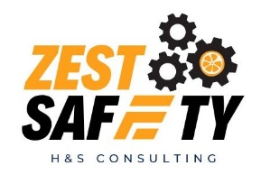
Disclaimer: This resource document has been created with the utmost care and accuracy, referencing the latest guidelines and information available at the time of production. However, businesses or individuals using this free resource are advised to independently verify the accuracy of the information provided. For comprehensive and tailored advice, it is recommended to engage a qualified health and safety advisor.
For further free H&S documents visit www.zestsafety.com

