

Standard Operating Procedure
Cordless Impact Driver

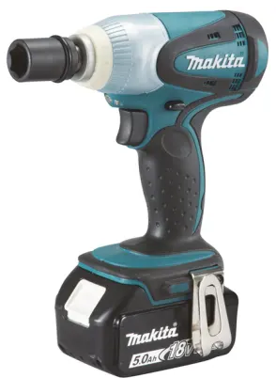
 | Dust Mask When required |  | Earmuffs/ Plugs  When required
 | Safety Glasses |  | Close fitting Clothing
 | Safety Footwear |  | Long and loose hair must  be contained or restrained

PRE-OPERATIONAL SAFETY CHECKS

1. Check condition of Driver and Battery for damage.

2. Connect correct battery to driver, recharge battery if necessary.

3. Select correct bit.

OPERATIONAL SAFETY CHECKS

1. Fit and hand tighten bit into keyless chuck.

2. Use firm pressure but do not force tool.

3. Allow driver to stop completely before setting down or changing bit.

HOUSEKEEPING

1. Switch off and leave Drill, bench and floor in a safe, clean and tidy state.

2. Make sure good housekeeping practices are in place to minimise any dust build-up.

POTENTIAL HAZARDS
Exposure to moving & rotating components Entanglement



FORBIDDEN
Using Driver for anything apart from its purpose.

Editing Instructions: note that the Zest Safety Logos can be deleted, and your own company logos inserted. Font Colours can be changed to your company colour palettes.

Disclaimer: This resource document has been created with the utmost care and accuracy, referencing the latest guidelines and information available at the time of production. However, businesses or individuals using this free resource are advised to independently verify the accuracy of the information provided. For comprehensive and tailored advice, it is recommended to engage a qualified health and safety advisor.
For further free H&S documents visit www.zestsafety.com



