

Standard Operating Procedure
Concrete Mixer

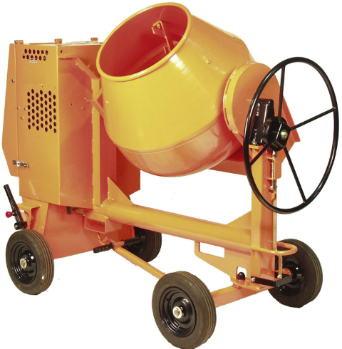
 | Dust Mask |  | Earmuffs/ Plugs
 | Safety Glasses |  | Close fitting Clothing
 | Safety Footwear

PRE-OPERATIONAL SAFETY CHECKS
- Ensure the mixer is in a suitable safe work area and select a firm, level and stable ground surface.
- Check condition of lead and plug.
- Confirm the mixer has a current electrical safety tag.
- Ensure that the power lead can be kept dry, off the ground and connected through an RCD safety switch.
- Ensure all safety guards are correctly fitted and secured.
- Ensure that the unit is mechanically sound.

OPERATIONAL SAFETY CHECKS
- Never use the electrical mixer outdoors in the rain.
- Never use the mixer without all guarding in place.
- Ensure the area does not contain any hazards that may impact on the safe operation of the mixer.
- Never insert your hands or shovel into a rotating mixer bowl.
- Be conscious of your manual handling techniques when adding cement powder, gravel or sand to the mixer bowl using a shovel (or similar).
- Regularly inspect the mixer bowel for consistency and suitability for the concrete mix.
- Never leave the mixer running unattended.

HOUSEKEEPING
- Empty the mixer drum of all contents.
- While still wet, wash out with clean water.
- Allow the mixer to revolve to wash the interior and carefully clean off the exterior.
- Disconnect the electrical AC power source.
- Clean up the work area.
- Return the mixer to a secure storage area.

POTENTIAL HAZARDS
Exposure to moving & rotating components Entrapment Electricity
Eye injury Manual handling Skin irritation from cement or additives

FORBIDDEN
Opening the motor housing without isolating the electrical connections
Placing hands anywhere near the drive teeth mechanism (between the motor and mixer bowl)


Editing Instructions: note that the Zest Safety Logos can be deleted, and your own company logos inserted. Font Colours can be changed to your company colour palettes.

Disclaimer: This resource document has been created with the utmost care and accuracy, referencing the latest guidelines and information available at the time of production. However, businesses or individuals using this free resource are advised to independently verify the accuracy of the information provided. For comprehensive and tailored advice, it is recommended to engage a qualified health and safety advisor.
For further free H&S documents visit www.zestsafety.com



