

Standard Operating Procedure
Pneumatic Brad Nailer

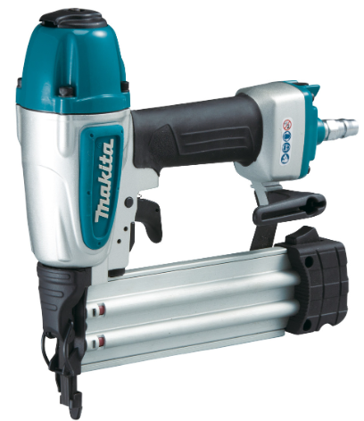

 | Dust Mask |  | Earmuffs/ Plugs
 | Safety Glasses |  | Close fitting Clothing
 | Safety Footwear |  | Long and loose hair must be  contained or restrained

PRE-OPERATIONAL SAFETY CHECKS
- Check area is clear of debris and well illuminated.
- Check condition of the tool and do not operate if not functioning properly.
- Make sure no one is in the vicinity before nailing.
- Do not use the tool in the vicinity of volatile or flammable materials.
- Make sure the safety mechanism is in working order before operation. First, disconnect the tool and open the magazine. Make sure the trigger can be pulled when you depress the contact arm against the work piece; the trigger cannot be pulled when you lift the tool from the work piece.

OPERATIONAL SAFETY CHECKS

1. Always assume the tool contains fasteners.

2. Never point the tool at yourself or anyone with or without fasteners – no horseplay.

3. Do not actuate the tool unless the tool is placed firmly against the work piece.

4. Do not hold or carry the tool with a finger on the trigger.

5. Do not load the tool with fasteners when anyone of the operating controls activated.

6. Maintain good footing and balance.

7. Place nails with care, avoid nails and knots.

8. Always disconnect the air hose and remove all nails: when unattended, before performing maintenance, before cleaning a jam and before moving the tool to another location.

HOUSEKEEPING
- Disconnect the tool from the air hose, remove nails.
- Make sure good housekeeping practices are in place to minimise any dust build-up.

POTENTIAL HAZARDS

Exposure to ejected nails Compressed Air Eye Injury
Splinters

Editing Instructions: note that the Zest Safety Logos can be deleted, and your own company logos inserted. Font Colours can be changed to your company colour palettes.

Disclaimer: This resource document has been created with the utmost care and accuracy, referencing the latest guidelines and information available at the time of production. However, businesses or individuals using this free resource are advised to independently verify the accuracy of the information provided. For comprehensive and tailored advice, it is recommended to engage a qualified health and safety advisor.
For further free H&S documents visit www.zestsafety.com



